**Given the provided data, what are three conclusions we can draw about Kickstarter campaigns?**

That the majority of the campaigns that have existed are related to the theater and music categories, with 63.1% (38.4% and 24.7%, respectively), likewise, the subcategories with the highest successful campaigns are plays and rock with 43.5% of the total of successful campaigns.

On the other hand, the categories with the lowest success rate are food in these campaigns within this category, only 19.5% were successful. Followed by the games category, of all the campaigns in this category, only 36.4% were considered successful.

The country has the highest participation in the US and GB campaigns, with 88.5% of all campaigns; likewise, these countries have 92.3% successful campaigns.

**What are some limitations of this dataset?**

* All sponsors have the same weight, and there is no distinction between them.
* It is not possible to infer the cost of the campaigns.
* The same level of creativity or originality in the content is assumed for all projects.

**What are some other possible tables and/or graphs that we could create?**

You can create a chart showing success by country with a stacked bar chart.

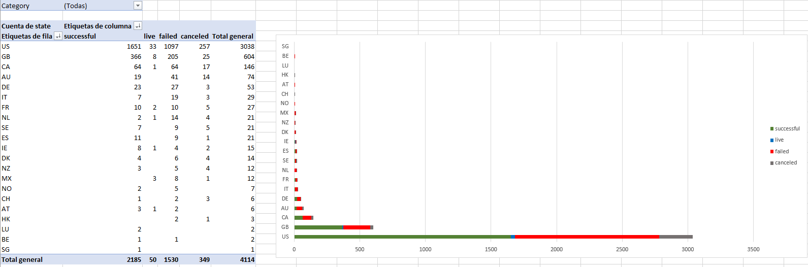

**Bonus Statistical Analysis.**

**Use your data to determine whether the mean or the median summarizes the data more meaningfully.**

The information and these summary tables show that the most successful campaigns had a greater number of sponsors, while the unsuccessful campaigns did not have any sponsors.

**Use your data to determine if there is more variability with successful or unsuccessful campaigns. Does this make sense? Why or why not?**

Yes, it makes sense derived from the fact that campaigns with little success are related to the fact that there are few sponsors. Vice versa, projects with few involved or little supported have a low probability of success. In contrast, projects (or supported campaigns) invest more in advertising and increase success probability.

However, depending on different circumstances such as quality, creativity, the results may be diverse, so the variability is broader, as observed in the data.